<Name of Project>

Change Management Plan



Document Revision History

Version Number | Date | Description

Overview
Describe the purpose of this project's change management plan. Provide an overview of the general process for the management of changes within the project

Change Process
Provide a diagrammatic representation of the processes and procedures to be undertaken in order to initiate, evaluate, review, and resolve change requests within the project. An example follows:
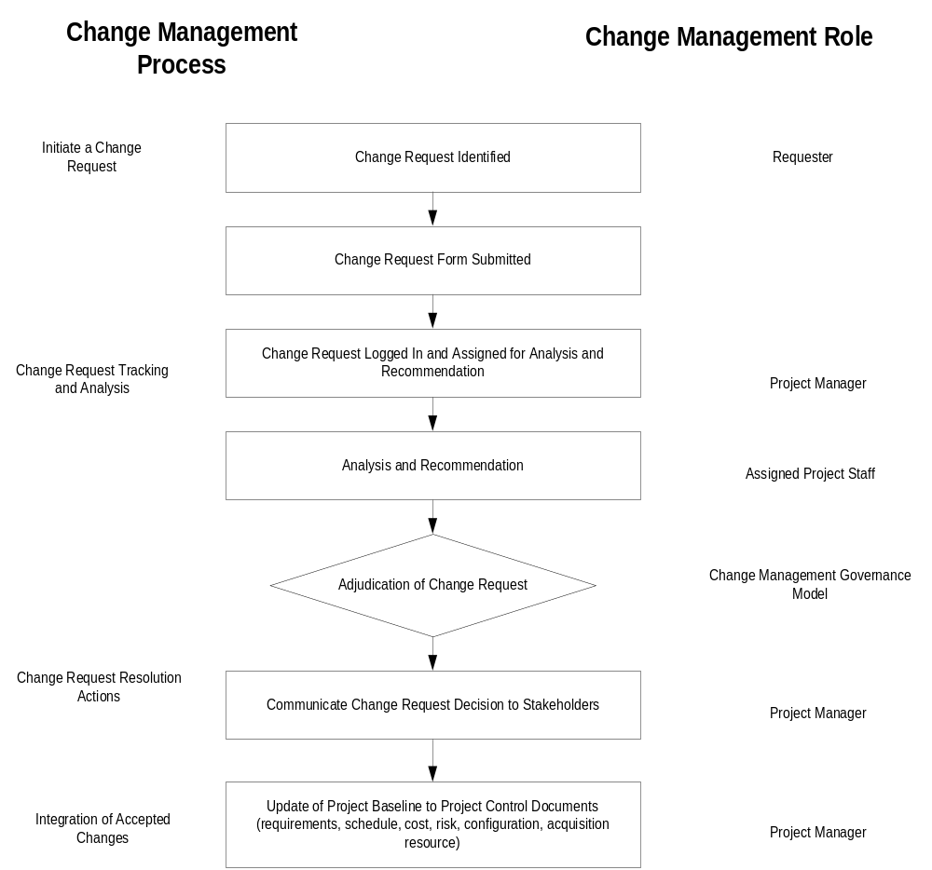

Change Management Roles
Define the roles and responsibilities for all resources - both within and external to the project - involved with the identification, review and resolution of change requests within the project

Change Request Log
Describe the purpose and usage of the "Change Request Log". Insert a blank copy of the actual Change Request Log with this plan.

Change Request Form
Describe the purpose and usage of the "Change Request Form". Insert a blank copy of the form with this plan.

